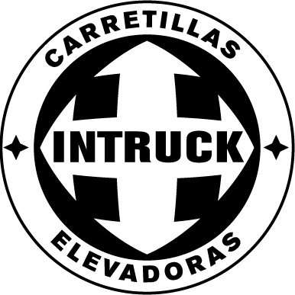

USER MANUAL Private Area

www.intruck.es

This INTRUCK Carretillas Elevadoras S.L. manual aims to provide a description of the functions offered in the private area of the website www.intruck.es, which may only be accessed by exclusive customers like yourself.

In this private area you can access totally updated information giving you a competitive edge over other companies in the sector, as you can find out the prices and condition of the machines before anyone else does, as well as receiving periodical information and special offers that we are sure will be of interest to you.

PIN Code Access

To access the private area, enter your chosen user name and password confirmed or validated by INTRUCK.

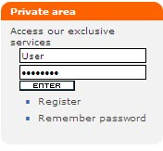

This welcome message will appear to show you have entered the private area specially designed for you:

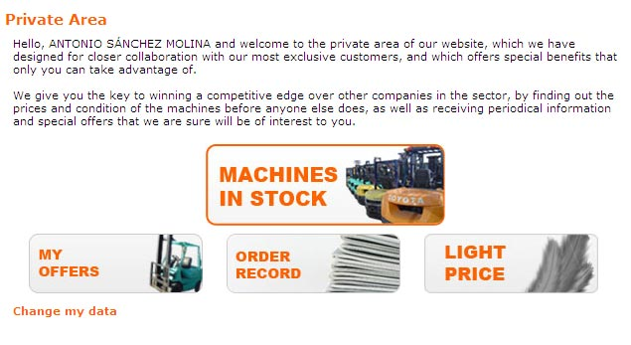

The following spaces and features can be directly accessed from this home page:

“Change my Data”: this option can be used to modify your data.
“Machines in Stock”: direct access to our stock of used forklift trucks and handling equipment.
“My Offers”: direct access to your offers.
“Order Record”: direct access to your orders.
“Light Price”: a direct link to see the machines with a ‘light price’.

Browsing the Catalogue

This section provides the same information as in the public part, but with a major difference: as a privileged user, you may access the price of each of the references, and also a full, exhaustive technical report or checklist describing the condition of the used forklift truck or item of handling equipment in full detail.

The search engine in the private part of the website is more complete, as it enables you to select the used forklift trucks and handling equipment by price or by those which have the checklist report available.

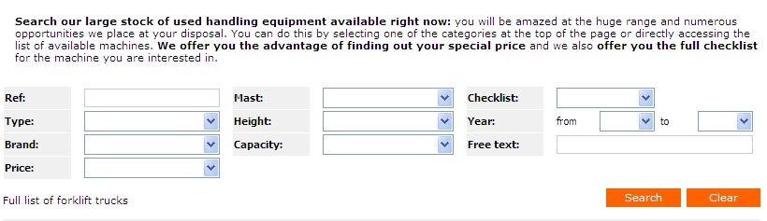

Another interesting advantage over the possibilities available in the public part is that you can select the machines you are most interested in and enter them on a “Trailer”. There are two ways to fill in the “Trailer”: either from the list, by clicking on the checklist reports, or from the detail file shown for each reference.

When you have selected the desired equipment, you can go to the trailer summary where you can view the machines you have loaded.

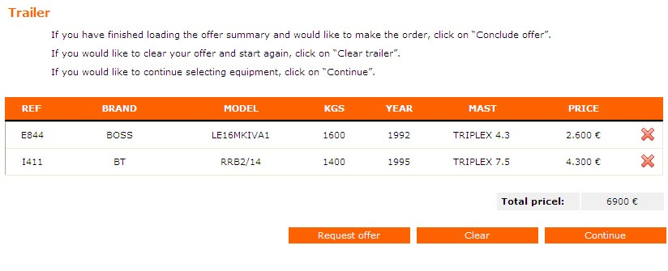
You have three options:
- Request an offer: This creates an e-mail to the sales officer for the geographical area closest to you.
- Clear: Removes all information from the trailer.
- Continue: enables you to continue adding items to the trailer.

You may also select the item or items you wish to erase without deleting the whole list, by clicking on the that appears on each line of the trailer summary.

Checklist

Another big advantage of this private area you have access to is a detailed technical report on the general condition of the used forklift truck or item of handling equipment selected. Data such as the condition of the motor, hydraulic system, electrical system, brakes and transmission, steering and structure will be shown fully and clearly, providing you with an honest and objective description of the state of the equipment.

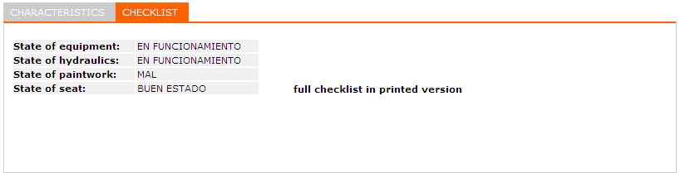

From here you can also view either the summary or the full checklist report and save or print them.

Order Record

Click on “Order Record” to access a list of all your orders in progress.


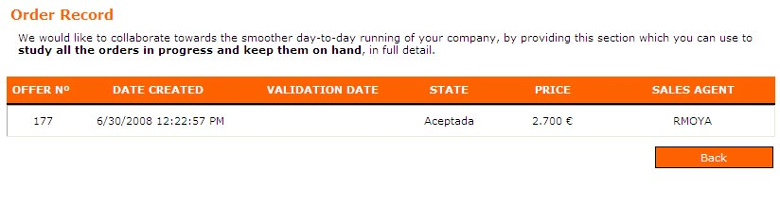

This section is for information and consultation purposes, and so it cannot be used to change the status of the order. A colour coding system shows whether the orders have been made or not, and you may consult the details for each one by clicking each order line in your record.

My Offers

Click on “My Offers” to access the list of all the offers made by INTRUCK, with information such as price, offer date, the sales agent who presented the offer, etc.

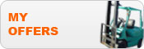

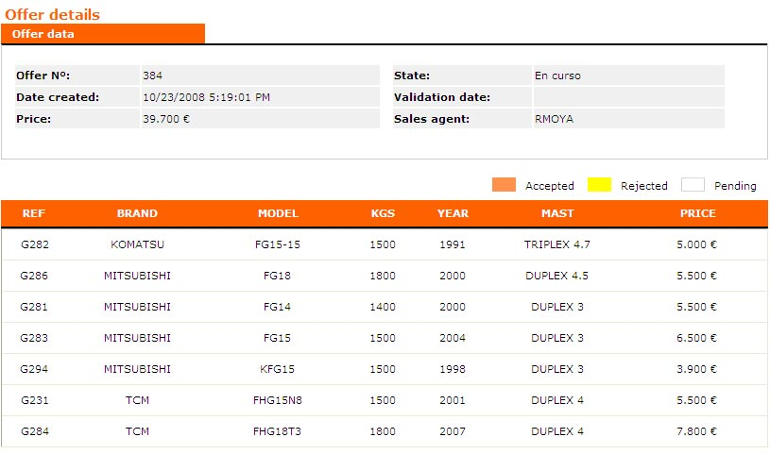

Change Personal Data

You may use this form to view and directly modify your personal data. The form will be sent to the sales officer in the area closest to you.
